Can you hear through a spoon?

Place the wool up near your ears, don’t push it in.
Can you hear anything?
Tap the spoon against the desk.
Can you hear anything?

What’s happening?
The sound waves are reverberating through the wool and into your ear drums.
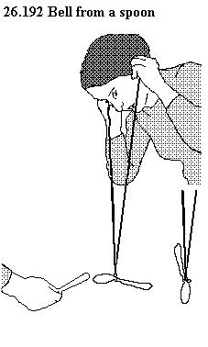
Wool is a conductor - it allows sound to travel through it.

Buzz it
Cover your comb with a piece of wax paper
Try to make a sound with it
Is it working?
Try holding the paper loosely
Hum into the comb
Stop the vibrations by holding the comb and paper. What was vibrating?

Straw whistle
Cut the end of a straw so it is a point. .
Do this to both ends
Flatten the straw at one end
Try to make the straw be a whistle

Two ears are better than one
Sit in a circle and one student in the middle with their eyes closed
Have one person clap. Can the student with their eyes closed tell where it is coming from?
Get the student in the middle to cover one ear.
Is it easier or harder to hear where the clap is coming from?

String Telephones
Get your string telephone and speak quietly into it
Can the other person hear you?
Gradually speak up until the other person can be heard.
Gently place your finger on the string while the other person is talking – can you feel the vibration?

